OO Programming Fundamentals

Practical Class 5 – Week 21st October 2013

- Create a new folder in your java folder on your G drive and call it practical05
- Save all the following exercises into the practical05 folder
- Ensure that you move to the correct folder when using the Command Prompt Window:
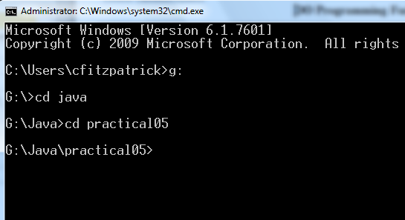
- You must run setpath from whichever folder it is stored in.

Exercise 1
Write a program which the user to enter a character a, b, or c and, using a nested if…else statement print the letter in CAPITALS to the screen. (Powerpoint Notes from class – on Moodle).
Save as ex5a.java

Sample Output:
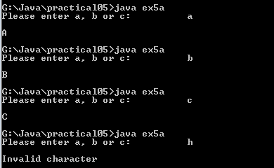

Exercise 2
Write a program which the user to enter a character a, b, or c and, using a switch statement print the letter in CAPITALS to the screen. (Powerpoint Notes from class – on Moodle).
Save as ex5b.java

Sample Output

Exercise 3
Write a program that presents a menu to the user.

***Marital Status***

Single (S, s)
Married (M, m)
Divorced (D,d)
In a Relationship (R,r)

- Ask the user to enter in their name:
- Ask the user to enter in their marital status s, m, d, r:
- Depending on their response, reply to them with an appropriate message "You are Single", "You are Married", etc.

Use a Switch statement
Save as ex5c.java
Sample Output:
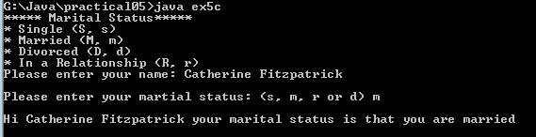

Exercise 4
Write a program that prints the following menu to the user:

COMPUTERS ‘R’ Us

--------------------------

Which product would you like to buy:
1. Computer
2. Laptop
3. Tablet
4. Exit
Enter your choice (1,2 or 3):

Use a Switch Statement to carry out the following:

- If the user entered a 1, print out that they chose a computer
- If the user entered a 2, print out that they chose a laptop
- If the user entered a 3, print out that they chose a tablet
- If the user enters 4 the program should end.
- If the user entered an invalid option e.g. 5, print out that they chose an invalid option, e.g.:
Save as ex5d.java
Sample Output
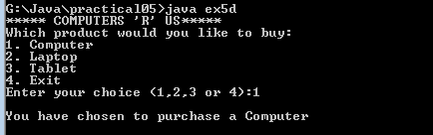

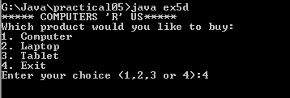

Exercise 5
Write a program that prints your name (not my name) to the screen 100 times. Use a For loop.
Save as ex5e.java
Sample Output:
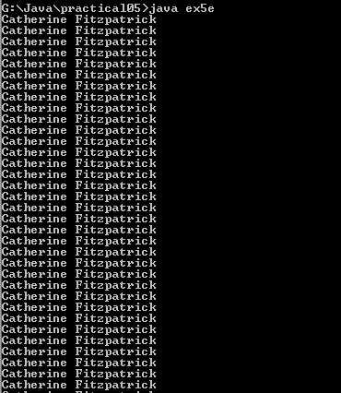

Exercise 6
Write a program which asks the user to enter their name and print that name to the screen 1000 times.
Save as ex5f.java
Sample Output:
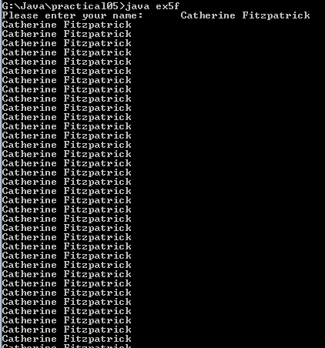

Exercise 7:
Write a program using a For statement to print the numbers from 1 to 10 inclusive.
Save file as ex5g.java
Sample Output

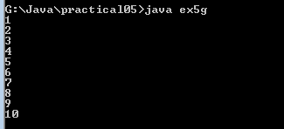

Exercise 8:

Write a program using a For statement to print the numbers from 10 to 1 inclusive.
Save file as ex5h.java
Sample Output
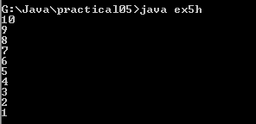

Completing this weeks’ Practical:
Zip Practical05 folder and upload the zipped file to Moodle.

